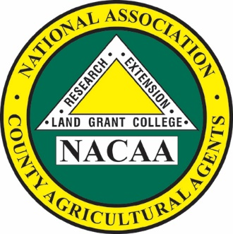

JJ Jones

*President*

111th Annual Meeting

July 8-12, 2026

Denver, Colorado

*NACAA is an Equal Opportunity*

*Professional Association*

**National Association of County Agricultural Agents**

NACAA Headquarters

6584 W. Duroc Road

Maroa, IL 61756

Phone: 217-794-3700 Fax: 217-794-5901

Email: exec-dir@nacaa.com

www.nacaa.com

President’s Address

JJ Jones

University of Arkansas

2301 S. University Avenue  
Little Rock, Arkansas 72204  
Phone:  501-671-2019  
Email: [jjjones@uada.edu](mailto:jjjones@uada.edu)